Blyth Valley Enterprise Limited (BVEL) – Rules and guidance for meeting room users.
- Please leave this guidance sellotaped to your table.
- You must complete a visitor form every day & submit it to reception. This is the responsibility of the individual/organisation who books the room.
- The centres meeting rooms have been deep-cleaned prior to reopening. Certification is displayed at reception. Meeting rooms will be thoroughly cleaned by centre management after every meeting before allowing anyone else to use the room. Please be patient.
- In the last fourteen days, if you have tested positive for COVID-19, been asked to self-isolate and/or shown any of the following symptoms/been in contact with anyone showing these symptoms: high temperature, new, continuous cough or loss or change to your/their sense of taste and/or smell, you must not enter the building under any circumstances.
- You must wear a face covering whilst in the building.
- At all times, maintain a distance of ideally two metres, but, at least one metre from other centre users/staff. If there is a speaker at the front of the room, please ensure that the speaker stands behind the hazard tape to the right of the television.
- Please try to talk quietly & avoid speaking loudly/shouting.
- Only one person should be seated at any table. Rooms are set-up accordingly.
- Use hand sanitizer stations regularly to wash your hands. Use paper towels to dry your hands. Dispose of your paper towels in the bin.
- Use the anti-bacterial spray & cloth to regularly wipe any “high-touch” areas within your meeting room. For example, the cold water dispenser button, the hot water flask dispenser button, the TV remote etc. Anti-bacterial spray should not be removed from your meeting room at any point, particularly at the end of your meeting. A charge of £5 will be levied on the person/organisation booking the room if this occurs.
- Please inform centre management immediately if your bins are full or you run out of any of the following: hand sanitizer, anti-bacterial spray or paper towels.
- Only one person at a time to use the toilets (vacant/engaged signs will be displayed on all outer toilet doors, with the exception of the disabled toilet). Please change the sign accordingly when you use the toilets.
- Use the same cup/mug & spoon throughout the day, if possible. Biscuits & buffets will not be provided until further notice. If you wish to bring your own food for attendees, this is allowed, however, you do so at your own risk.
- If possible, increase ventilation through opening the windows/doors.
- Capacity of meeting rooms is limited, to allow for social distancing. It is the responsibility of the individual/organisation booking the room to ensure that social distancing is adhered to within the meeting room. The pictures below were taken in “normal times” & the set-up of the rooms will be different to allow for social distancing compliance. Please note that it is the booker’s responsibility to ensure the meeting complies with any government restrictions, for example, “support groups” are limited to a maximum of 15 attendees. When booking, you will be asked to confirm that to the best of your knowledge your meeting complies with English COVID-19 gathering regulations/guidelines. The capacity of each room is now as follows:
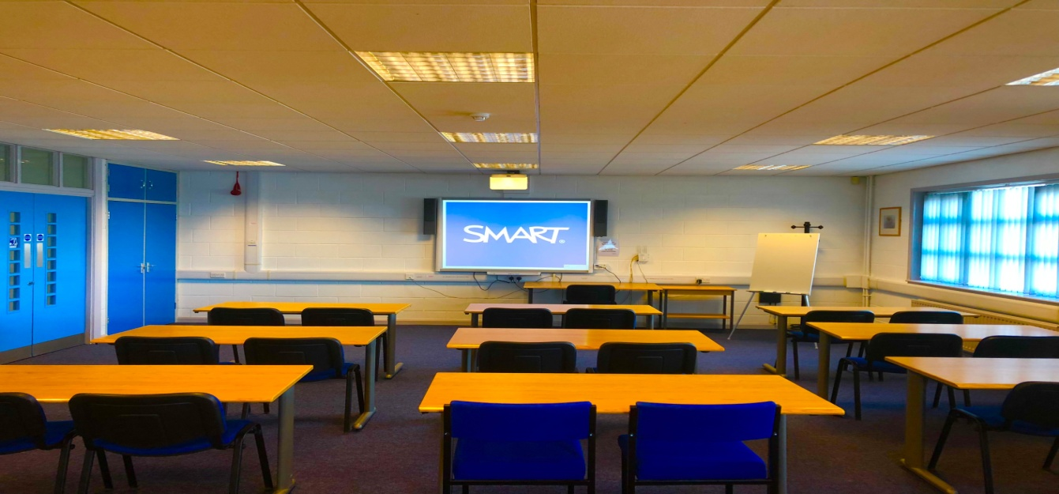
Room G01 (the ground floor meeting room directly to the left of reception): No more than 18 people.
Room G01.

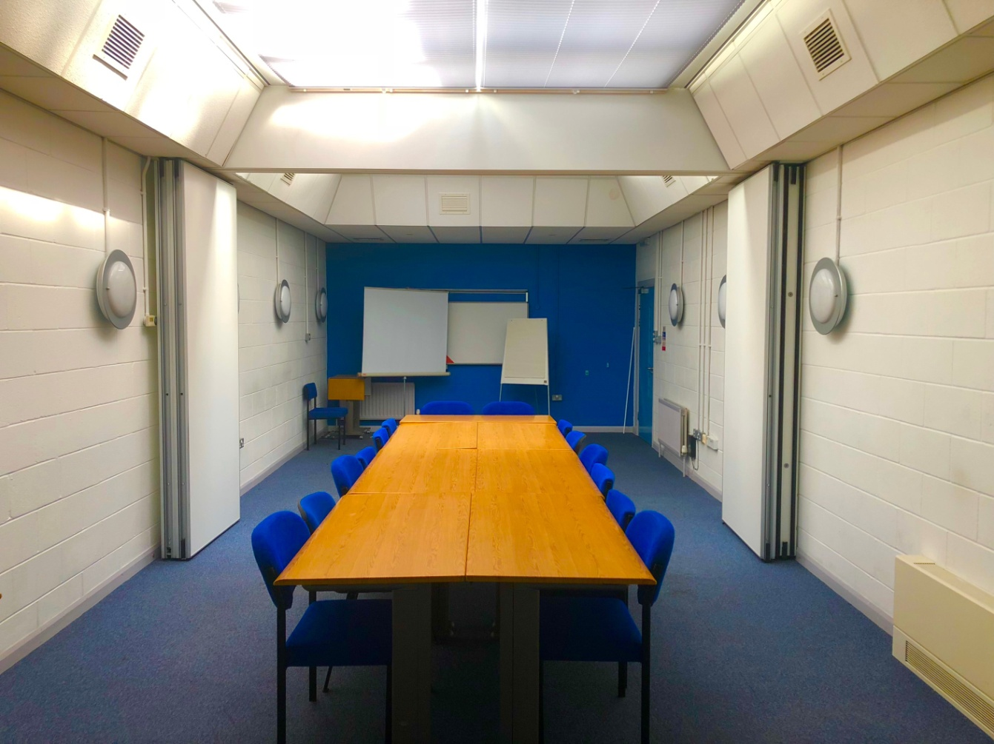
Rooms 101/102 (the first floor meeting room): No more than 12 people.
Rooms 101/102.
Any other meeting room: No more than 4 people.

